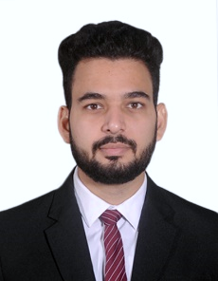**VARUN GAUR**

DOB: 15th March 1997

Sector-15, Rohini

New Delhi: 110089

+91 8800114041

Shivamgaur33@gmail.com

**OBJECTIVE**

By acquiring knowledge, expertise and a familiarity with the organization’s culture, I want to contribute towards realizing organization’s vision and become its integral part.

**EDUCATION**

**Masters of Business Administration Result Awaited**

***Gitarattan International Business School, Delhi (Affiliated to GGSIPU, Delhi)* (2020)**

Specialization: Major- Marketing, Minor- IB

Percentage: 70%

**Bachelors of Commerce with Honours July 2018**

***Kasturi Ram College Of Higher Education, Narela (Affiliated to GGSIPU, Delhi)***

Percentage: 70%

**Higher Secondary June 2015**

***Jain Bharti Model School CBSE, Delhi***

Percentage: 65%

**Matriculation June 2013**

***Titiksha Public School CBSE, Delhi***

Percentage: 60%

**INTERNSHIP EXPERIENCE**

**Fresca as *Summer Trainee (Marketing)* June – July 2019**

**Role:**

* Dealing with the clints of fresca in the area of Faridabad.
* Promoting the product which were recently launched by Fresca.

**CO/EXTRA CURRICULAR ACTIVITIES**

* Joint secretary at Rotract Club District 3012.

**OTHER**

**Computer Skills** MS Word, MS Excel Advance.

**Languages** Reading, Speaking proficiency in Hindi and English

I hereby declare that the above furnished information is true to the best of my knowledge and belief.

**Date: Signature of the Candidate**

**Place:**